Copyright for test papers and marking guides remains with West Australian Test Papers.
Test papers may only be reproduced within the purchasing school according to the advertised Conditions of Sale.
Test papers should be withdrawn after use and stored securely in the school until 14th October 2019.



SEMESTER TWO

MATHEMATICS
SPECIALIST
UNITS 3 & 4

2019

SOLUTIONS

Calculator−Free Solutions

1. $\overline{z}+\frac{z}{i}=\left(a-bi\right)+\frac{a+bi}{i}=\left(a+b\right)-\left(a+b\right)i$
i.e. $Re\left(\overline{z}+\frac{z}{i}\right)=-Im\left(\overline{z}+\frac{z}{i}\right)$
i.e. the complex number lies on the line $y=-x$
$∴\arg\left(\overline{z}+\frac{z}{i}\right)=-\frac{π}{4} or \frac{3π}{4}$ [5]

2. (a) $z^{3}=-8=8\operatorname{cis}\left(π+2kπ\right)$
$∴z=2\operatorname{cis}\left(\frac{π+2kπ}{3}\right) for k=0, ±1$
$z_{0}=2\operatorname{cis}\left(\frac{π}{3}\right), z_{1}=2\operatorname{cis}\left(π\right) , z_{3}=2\operatorname{cis}\left(-\frac{π}{3}\right)$
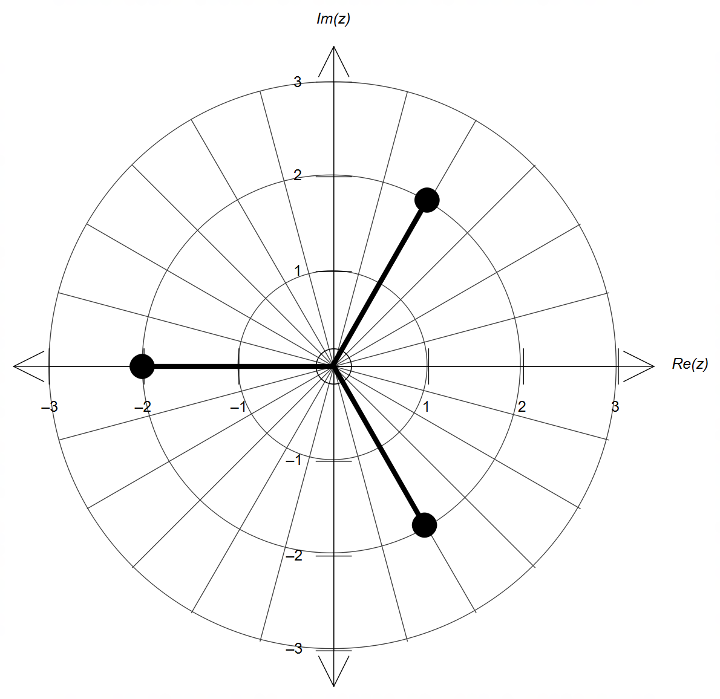
(b)

magnitude = 2

$\frac{2π}{3}$ radians apart

(c) $P\left(z\right)=\left(z^{3}+8\right)\left(z^{2}+bz+c\right)=z^{5}-z^{4}-2z^{3}+8z^{2}-8z-16$
$∴8c=-16 → c=-2$
expanding with $c=-2$ gives:
$P\left(z\right)=z^{5}+bz^{4}-2z^{3}+8z^{2}+8bz-16$
and therefore $b=-1$ and $c=-2$
(division of polynomials is also possible)
Hence, $Q\left(z\right)=z^{2}-z-2=\left(z-2\right)\left(z+1\right)$

(d) $∴P\left(z\right)=\left(z^{3}+8\right)\left(z-2\right)\left(z+1\right)$
$∴z=-1, ±2 and 1±\sqrt{3}i$ [10]

3. (a) $x=2\tan\left(θ\right) → \frac{dx}{dθ}=\frac{2}{\cos^{2}{θ}} → dx=\frac{2dθ}{\cos^{2}{θ}}$
$θ\left(x\right)=\tan^{-1}\left(\frac{x}{2}\right) → θ\left(0\right)=0 and θ\left(2\right)=\frac{π}{4}$
$∴a=0 and b=\frac{π}{4}$
$\sqrt{x^{2}+4}=\sqrt{4\tan^{2}{θ}+4}=\sqrt{4\left(\tan^{2}{θ}+1\right)}=\sqrt{\frac{4}{\cos^{2}{θ}}}$
$∴\sqrt{x^{2}+4}=\frac{2}{\cos{θ}}$
$$∴\int_{0}^{2}{\frac{x}{\sqrt{x^{2}+4}}dx}=\int_{0}^{\frac{π}{4}}{\frac{2\tan{θ}}{\left(\frac{2}{\cos{θ}}\right)}×\frac{2dθ}{\cos^{2}{θ}}}=\int_{0}^{\frac{π}{4}}{\frac{2\tan{θ}}{\cos{θ}}dθ }$$

(b) Using the substitution recommended in (a):
$$\int_{0}^{\frac{π}{4}}{\frac{2\tan{θ}}{\cos{θ}}dθ}=2\int_{0}^{\frac{π}{4}}{\frac{\sin{θ}}{\cos^{2}{θ}}dθ}=2\int_{0}^{\frac{π}{4}}{\sin{θ}\cos^{-2}{θ}dθ}$$
$=2{\left[-\frac{\cos^{-1}{θ}}{-1}\right]}_{0}^{\frac{π}{4}}=2{\left[\frac{1}{\cos{θ}}\right]}_{0}^{\frac{π}{4}}=2\left[\frac{1}{1/{\sqrt{2}}}-\frac{1}{1}\right]=2\left(\sqrt{2}-1\right)$ [4]
(other method is possible by setting $u=x^{2}$)

4. (a) $f\left(x\right)=\frac{x\left(x^{2}-5x+4\right)}{\left(x-1\right)}=\frac{x\left(x-4\right)\left(x-1\right)}{\left(x-1\right)}=x\left(x-4\right)$ provided $x≠1$
$∴D_{x}=\left\{x∈R:x≠1\right\}$
$R_{y}=\left\{y∈R:y≥-4 ∧ y≠-3\right\}$
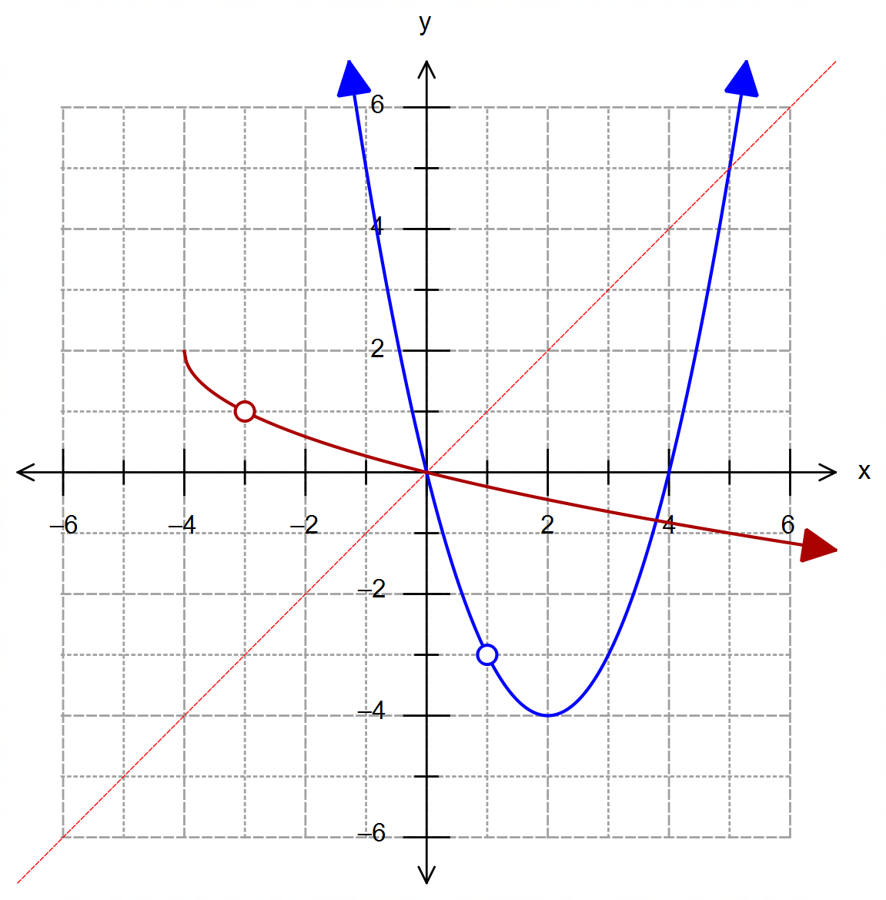
(b)
(b)
parabola with roots at x=0 and 4, with tp at (2,-4)
discontinuity at (1,-3)

(d)
square root function
with tp at (-4,2)
discontinuity at (-3,1)
4. (c) Turning point at $\left(2,-4\right) → ∴x≤2 → k=2$
Algebraically by rearranging to make $x$ the subject
gives $f^{-1}\left(x\right)=2-\sqrt{x+4}$

(d) Shown on the graph in (b). [10]

5. (a) $\left|r-2j\right|=4$

(b) The line can be obtained from two points, by choosing
any two different values of $λ$.
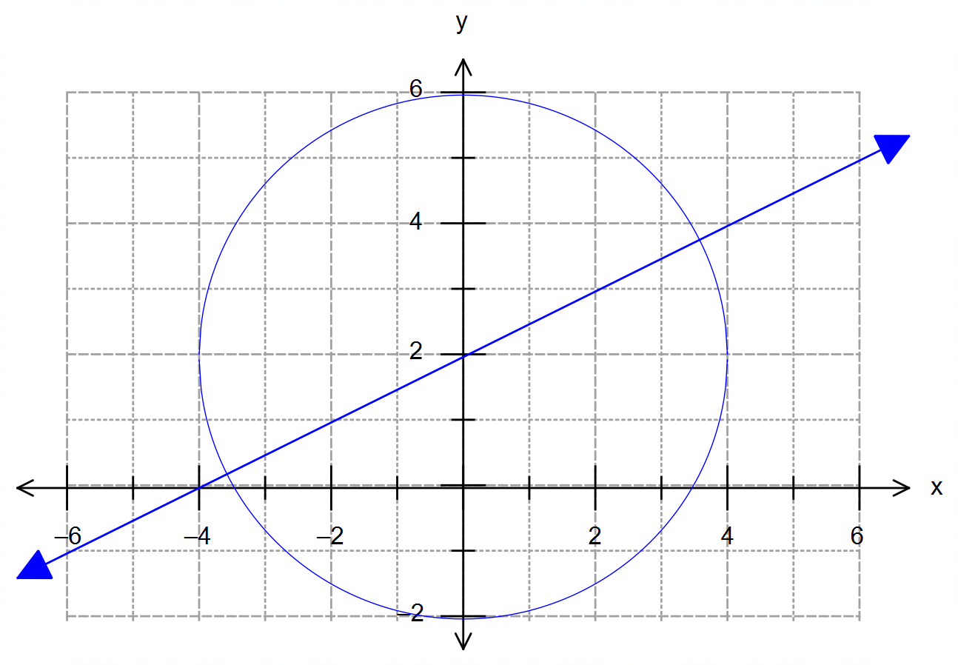

line $y=\frac{x}{2}+2$

$\left|\left(\begin{matrix}2λ-2 \\ λ+1\end{matrix}\right)-\left(\begin{matrix}0 \\ 2\end{matrix}\right)\right|=\left|\begin{matrix}2\left(λ-1\right) \\ λ-1\end{matrix}\right|=4$
$∴4{\left(λ-1\right)}^{2}+{\left(λ-1\right)}^{2}=16$
$5{\left(λ-1\right)}^{2}=16 → λ=1±\frac{4}{\sqrt{5}}$
$∴r\left(1±\frac{4}{\sqrt{5}}\right)=\left(\begin{matrix}2\left(1±\frac{4}{\sqrt{5}}\right)-2 \\ 1±\frac{4}{\sqrt{5}}+1\end{matrix}\right)=\left(\begin{matrix}±\frac{8}{\sqrt{5}} \\ 2±\frac{4}{\sqrt{5}}\end{matrix}\right)$ [6]

6. (a) Choosing the polar point ${\left(4, 2π\right)}^{P}$:
$\arg\left(z\right)=2π → \left|z\right|=k\left(2π \right)+1=4 ∴k=\frac{3}{2π}$
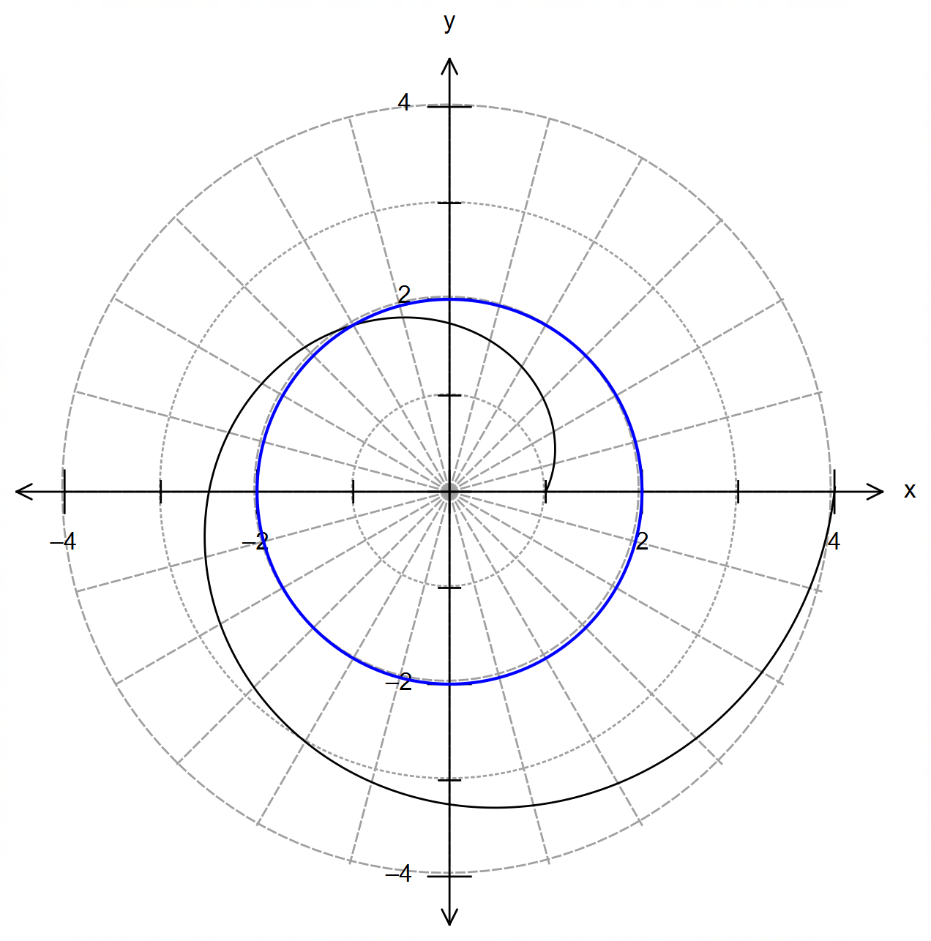 (b)

circle cented at O
with radius 2

(c) Using $\left|z\right|=2$:
$2=\frac{3}{2π}\arg\left(z\right)+1 → \arg\left(z\right)=\frac{2π}{3}$
$∴w=2\operatorname{cis}\left(\frac{2π}{3}\right)=2\cos\left(\frac{2π}{3}\right)+2i\sin\left(\frac{2π}{3}\right)=-1+\sqrt{3}i$ [6]

7. (a) Area of a segment: $A=\frac{r^{2}}{2}\left(θ-\sin{θ}\right)$
$∴A=\frac{{\left(1/2\right)}^{2}}{2}\left(2θ-\sin\left(2θ\right)\right)=\frac{1}{8}\left(2θ-\sin{2θ}\right)$
$∴V=A×l=\frac{1}{8}\left(2θ-\sin{2θ}\right)×8=2θ-\sin{2θ}$
(b) $\frac{dV}{dθ}=2-2\cos{2θ}$
(c) $\cos{θ}=\frac{\frac{1}{2}-x}{1/2}=1-2x$
$∴x=\frac{1}{2}-\frac{1}{2}\cos{θ}$
$\frac{dx}{dt}=0-\frac{1}{2}×-\sin{θ}×\frac{dθ}{dt}=\frac{1}{2}\frac{\sin{θ}dθ}{dt}$

(d) $\frac{dθ}{dt}=\frac{dθ}{dV}×\frac{dV}{dt}=\frac{0.1}{2-2\cos{2θ}}$
$∴\frac{dx}{dt}=\frac{1}{2}\sin{θ}×\frac{0.1}{2-2\cos{2θ}}=\frac{\sin{θ}}{40\left(1-\cos{2θ}\right)}$
when $x=\frac{1}{4}$ m we obtain $θ=\frac{π}{3}$
$∴{\left.\frac{dx}{dt}\right|}_{θ=\frac{π}{3}}=\frac{\sin\left(\frac{π}{3}\right)}{40\left(1-\cos\left(\frac{2π}{3}\right)\right)}=\frac{\frac{\sqrt{3}}{2}}{40\left(1+\frac{1}{2}\right)}=\frac{\sqrt{3}}{120} \left[\frac{m^{3}}{min}\right]$ [8]

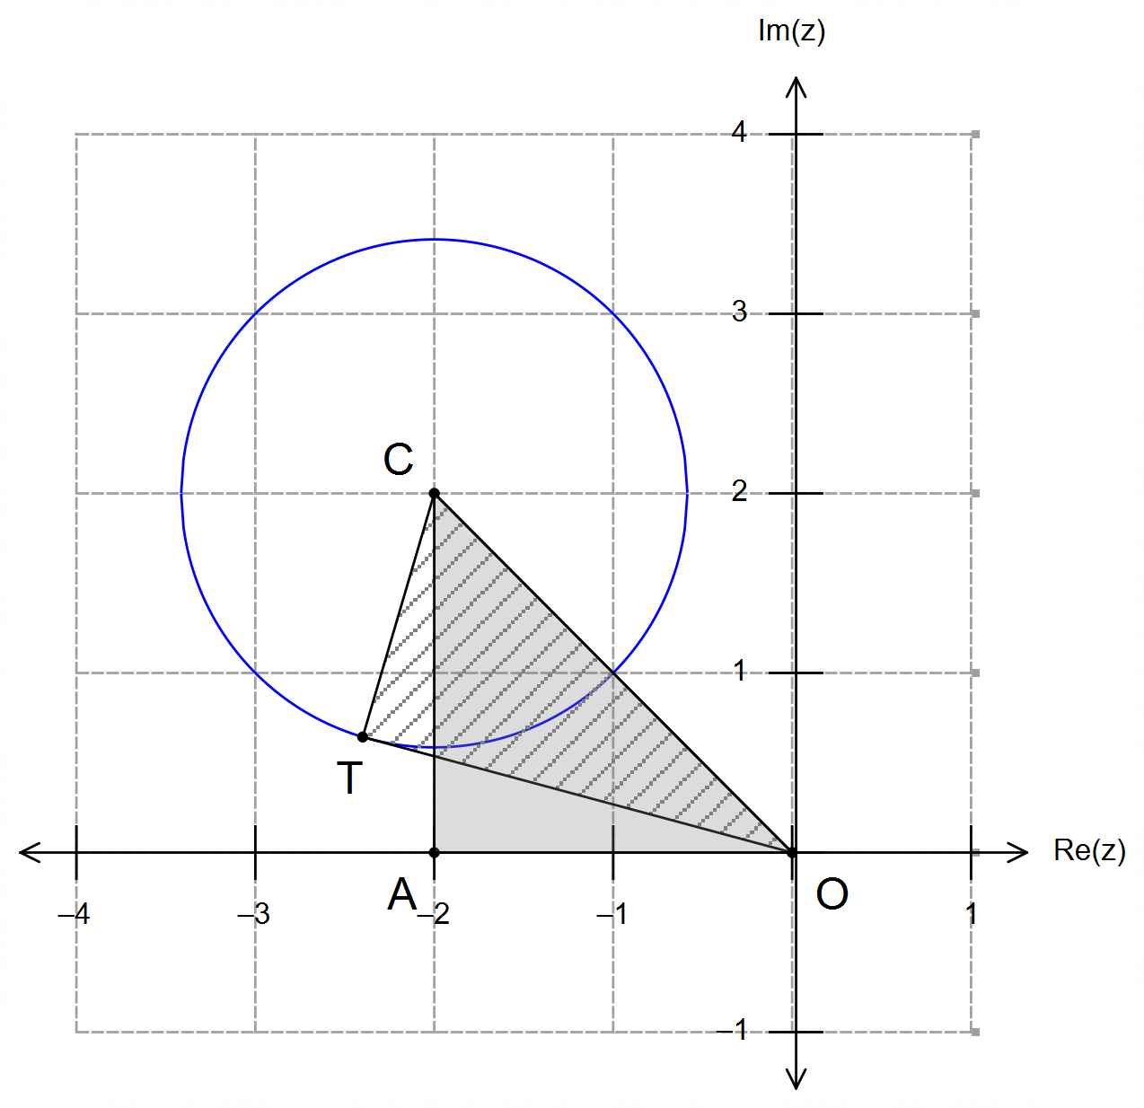Calculator−assumed Solutions

8. From the diagram we obtain two
right angled triangles:
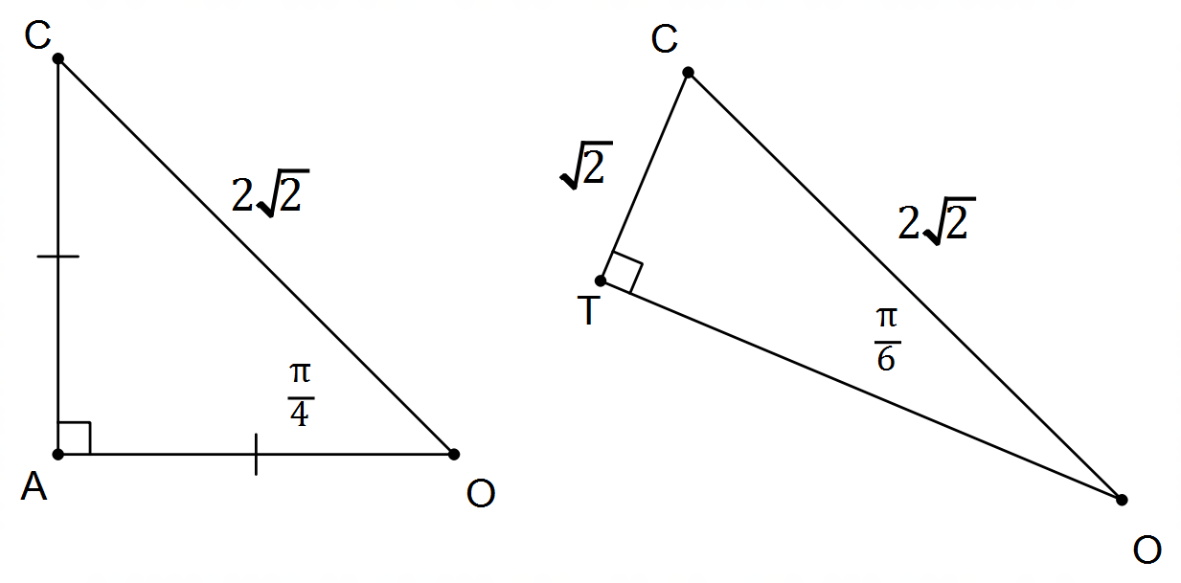

And therefore we have:
${\left|z\right|}_{min}=2\sqrt{2}-\sqrt{2}=\sqrt{2}$
${\left|z\right|}_{max}=2\sqrt{2}+\sqrt{2}=3\sqrt{2}$
${\arg\left(z\right)}_{min}=\frac{3π}{4}-\frac{π}{6}=\frac{7π}{12}$
${\arg\left(z\right)}_{max}=\frac{3π}{4}+\frac{π}{6}=\frac{11π}{12}$ [5]

9. (a) $\overline{T}\sim N\left(15,\frac{300}{30}\right)$
$∴σ^{2}\left(\overline{T}\right)=10 → σ\left(\overline{T}\right)=\sqrt{10}≈3.16$
$∴P\left(5≤\overline{T}≤15\right)=0.8862≈0.89$ (2dp.)

(b)
Normal distribution
centred at $μ\left(\overline{T}\right)=10$
Indicates a standard
deviation of approx. 3 min
Refers to (a) with area
shaded
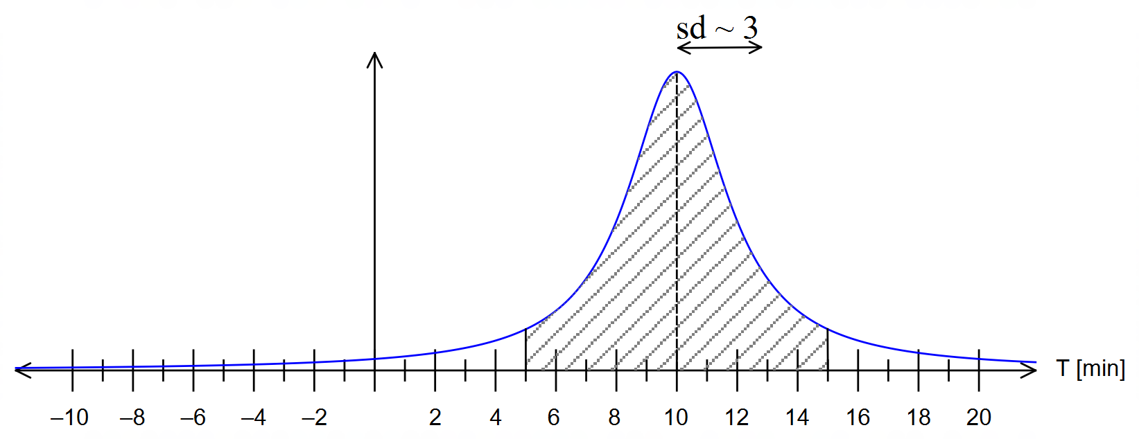

[6]

10. (a) $y=-2\left|x+3\right|+4$
$∴a=-2, b=3, c=4$

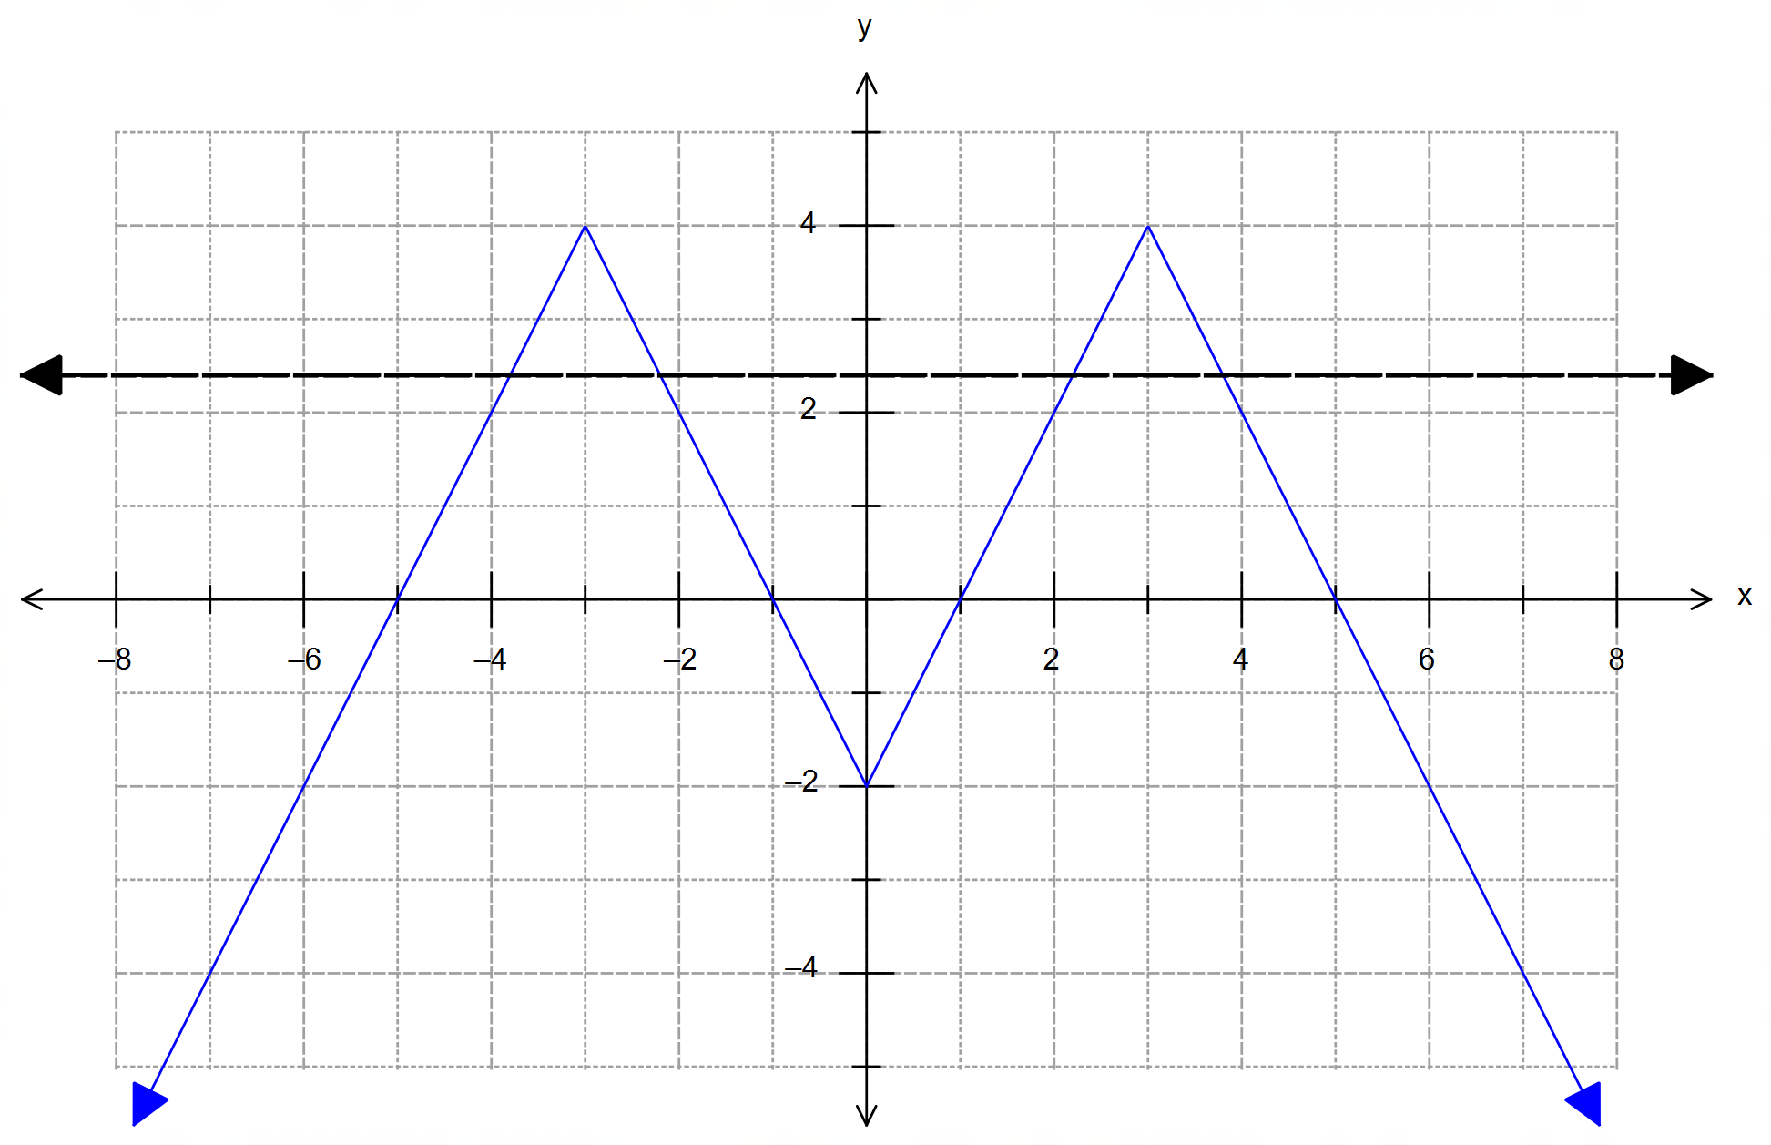 (b) The diagram below shows $f\left(-\left|x\right|\right)$:

Thefore, a horizontal line $y=d$ would intersect the graph
for $-2<d<4$. [6]
(graphical explanation can be accepted)

11. (a) $\vec{OM}=\left(\begin{matrix}120 \\ -80 \\ 40\end{matrix}\right)+t\left(\begin{matrix}2 \\ 1 \\ -1\end{matrix}\right)=\left(\begin{matrix}x \\ y \\ 0\end{matrix}\right)=$ location of ground collision
$∴40-t=0 → t=40$ seconds
$∴\vec{OM}\left(40\right)=\left(\begin{matrix}120 \\ -80 \\ 40\end{matrix}\right)+40\left(\begin{matrix}2 \\ 1 \\ -1\end{matrix}\right)=\left(\begin{matrix}200 \\ -40 \\ 0\end{matrix}\right)$
and $\left|\vec{OM}\left(40\right)\right|=\left|\begin{matrix}200 \\ -40 \\ 0\end{matrix}\right|=40\left|\begin{matrix}5 \\ -1 \\ 0\end{matrix}\right|=40\sqrt{26}≈203.96 km$ from O

(b) $\vec{OM}=\left(\begin{matrix}120 \\ -80 \\ 40\end{matrix}\right)+t\left(\begin{matrix}2 \\ 1 \\ -1\end{matrix}\right)=\left(\begin{matrix}x \\ y \\ 10\end{matrix}\right)=$ point 10 km above ground
$∴40-t=10 → t=30$ sec from detection time
$∴\vec{OM}\left(30\right)=\left(\begin{matrix}120 \\ -80 \\ 40\end{matrix}\right)+30\left(\begin{matrix}2 \\ 1 \\ -1\end{matrix}\right)=\left(\begin{matrix}180 \\ -50 \\ 10\end{matrix}\right)$
$\left(\begin{matrix}180 \\ -50 \\ 10\end{matrix}\right)-\left(\begin{matrix}20 \\ 160 \\ 0\end{matrix}\right)=\left(\begin{matrix}160 \\ -210 \\ 10\end{matrix}\right)$ displacement vector for ABM
$∴speed=\frac{1}{30}\left|\begin{matrix}160 \\ -210 \\ 10\end{matrix}\right|=\frac{\sqrt{698}}{3}≈8.81 km/s$

11. (c) (Using the conditions for collision will show that they do
not collide. If no other work is shown then award two marks for this attempt)
Using closest-approach method with CAS: f_{min}
$\vec{OM}=\left(\begin{matrix}2t+120 \\ t-80 \\ 40-t\end{matrix}\right)$ and $\vec{ABM}=\left(\begin{matrix}20+4.6t \\ 160-5.25t \\ 0+0.042t\end{matrix}\right)$
$∴{{}_{ABM}^{ }r}_{OM}=\vec{ABM}-\vec{OM}=\left(\begin{matrix}2.6t-100 \\ 240-6.25t \\ 1.042t-40\end{matrix}\right)$
$∴\left|{{}_{ABM}^{ }r}_{OM}\right|=\sqrt{{\left(2.6t-100\right)}^{2}+{\left(240-6.25t\right)}^{2}+{\left(0.042t-40\right)}^{2}}$
CAS:f_{min} $→ {\left|{{}_{ABM}^{ }r}_{OM}\right|}_{min}≈0.15 km$ for $t=38.41 s$ [13]

12. (a) ${\left.\frac{dy}{dx}\right|}_{\left(0,2\right)}=\frac{1}{2\left(0\right)+2}=\frac{1}{2}$

(b) The slope is undefined at $x=-1$

(c) $\frac{dy}{dx}=\frac{1}{2\left(x+1\right)} → 2dy=\frac{dx}{x+1}$
$$∴\int{2dy}=\int{\frac{dx}{x+1}}$$
$∴2y=\ln\left|x+1\right|+C_{1}$
$y=\frac{1}{2}\ln\left|x+1\right|+C_{2}=\ln{\sqrt{x+1}}+C_{2}$
$\left(0,2\right) → 2=\ln{\sqrt{1}}+C_{2} → C_{2}=2$
$∴y=\ln{\sqrt{x+1}}+2=\ln{e^{2}\sqrt{x+1}}$ [7]

13. (a) $\overline{X}$ is approximately normally distributed as the sample
size $n=40>30$
$∴\overline{X}\sim N\left(8,\frac{8^{2}}{40}\right)=N\left(8, 1.6\right)$
i.e. $σ\left(\overline{X}\right)=\sqrt{1.6}≈1.2649$

(b) $P\left(5<\overline{X}<11\right)=0.9823$

(c) No, there is no change.
Because the sample size $\left(40>30\right)$ provides a normal
distribution for the sample means, despite the shape
of the parent distribution.

13. (d) $P\left(\overline{X}>10\right)=0.05$
and $\overline{X}\sim N\left(8,\frac{8^{2}}{n}\right)$, i.e. $σ\left(\overline{X}\right)=\frac{8}{\sqrt{n}}$
If $P\left(z>k\right)=0.05 → k=1.6448$
$∴\frac{10-8}{\left(\frac{8}{\sqrt{n}}\right)}=1.6448 → n=43.29≈44$ [11]

14. (a) (i) $\frac{d\left(x\cos{x}\right)}{dx}=\cos{x}-x\sin{x}$
(ii) $d\left(x\cos{x}\right)=\cos{x}dx-x\sin{x}dx$
$$∴\int_{0}^{π}{d\left(x\cos{x}\right)}=\int_{0}^{π}{\cos{x}dx}-\int_{0}^{π}{x\sin{x}dx}$$
$$\int_{0}^{π}{x\sin{x}dx}=\int_{0}^{π}{\cos{x}dx}-\int_{0}^{π}{d\left(x\cos{x}\right)}$$
$={\left[\sin{x}\right]}_{0}^{π}-{\left[x\cos{x}\right]}_{0}^{π}$
$=\left[\sin{π}-\sin{0}\right]-\left[π\cos{π}-0\right]$
$=-\left[-π\right]=π$

(b) $x^{2}-x-2=\left(x-2\right)\left(x+1\right)$
Let $\frac{3}{x^{2}-x-2}=\frac{A}{x-2}+\frac{B}{x+1}$
then: $3=A\left(x+1\right)+B\left(x-2\right)$
for $x=2 → 3=3A+0 →A=1$
for $x=-1 → 3=0-3B →B=-1$
$$\int{\frac{3}{x^{2}-x-2}dx}=\int{\frac{dx}{x-2}}-\int{\frac{dx}{x+1}}$$
$=\ln\left|x-2\right|-\ln\left|x+1\right|+C$
$=\ln\left|\frac{x-2}{x+1}\right|+C$ [8]

15. (a) $\frac{dQ}{dt}=k\left(100-Q\right)=-k\left(Q-100\right)$
$$∴\int{\frac{dQ}{Q-100}}=-\int{kdt}$$
$\ln\left|Q-100\right|=-kt+C$
$Q-100=e^{-kt+C}=e^{C}×e^{-kt}=Ae^{-kt}$
$∴Q\left(t\right)=Ae^{-kt}+100$

15. (b) $Q\left(0\right)=A+100=900 → A=800$
$2.5 hrs=150 min$
$∴Q\left(150\right)=800e^{-150k}+100=450$
$→ e^{-150k}=\frac{350}{800} → k=\frac{\ln\left(\frac{7}{16}\right)}{-150}≈0.0055$
$∴Q\left(t\right)=800e^{-0.0055t}+100$
Since exponential decay never crosses the x-axis, we must
choose the first value that would round to zero.
i.e. $Q\left(t\right)=100.49$ (other values less than 100.5 are acceptable)
$Q\left(t\right)=800e^{-0.0055t}+100=100.49$
$e^{-0.0055t}=\frac{0.49}{800} → t=\frac{\ln\left(\frac{0.49}{800}\right)}{-0.0055}≈1345.08≈1345 min$ [7]

16. (a) $\frac{dB}{dt}=rB\left(k-B\right)$ from formula sheet
(b) $B\left(t\right)=\frac{5000}{1+Ae^{-kt}}$ from formula sheet, with 5000 as limit
$∴B\left(15\right)=\frac{5000}{1+Ae^{-15k}}=2278$ and $B\left(25\right)=\frac{5000}{1+Ae^{-25k}}=4304$
solving simultaneously: CAS $→A=24, k=0.2$
$∴B\left(t\right)=\frac{5000}{1+24e^{-0.2t}}$
(c) Since the line $y=5000$ is the upper asymptote, it will never
actually reach 5000. Therefore we must choose the first value
that would round to 5000:
$B\left(t\right)=\frac{5000}{1+24e^{-0.2t}}=4999.5$
CAS $→ t=61.94 hrs=61:56 hrs$ [7]

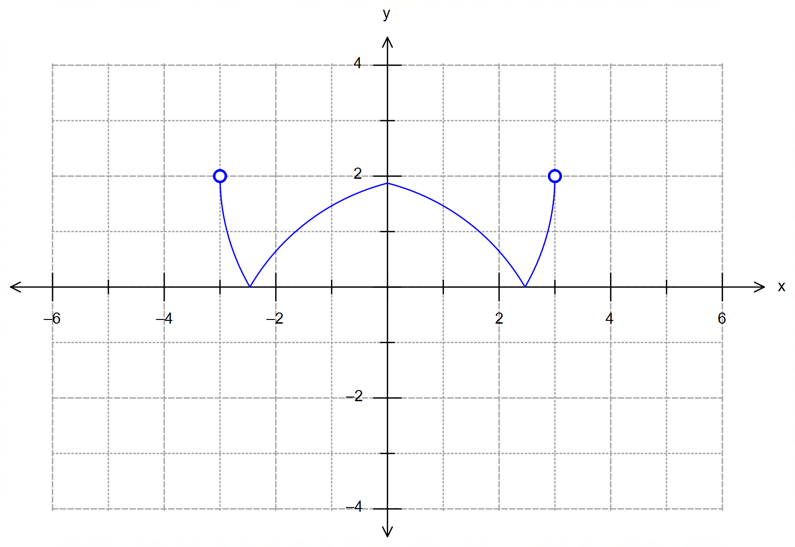17. (a) (i)
reflection over x axis

reflection over y axis

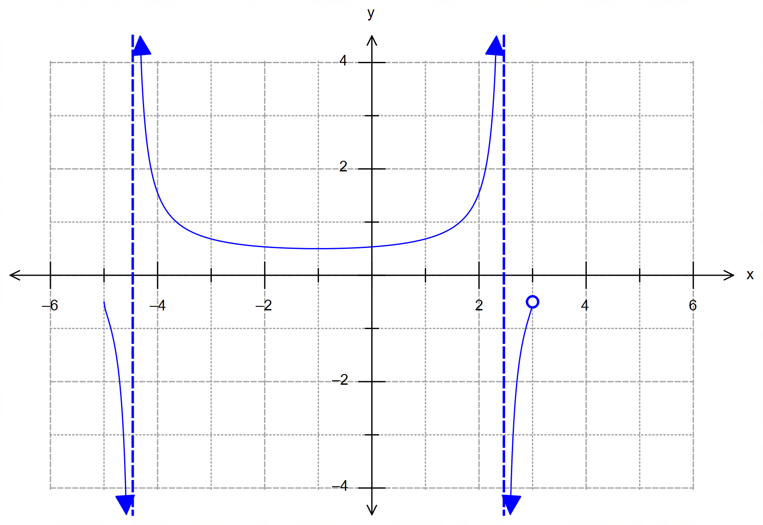17. (a) (ii)
vertical asymptotes
at the roots of the circle

crosses the original
function at points $y=±1$

behaviour on either side
of the asymptotes

(b) (i) $h∘f\left(x\right)=h\left(f\right)=\frac{1}{{\left(4-f\right)}^{2}}=\frac{1}{{\left(4-4+4\sqrt{x-1}\right)}^{2}}=\frac{1}{16\left(x-1\right)}$

(ii) For $h\left(x\right)$: ${\left(4-x\right)}^{2}≠0$
$∴{\left(4-f\right)}^{2}≠0$
$4-f≠0 → \sqrt{x-1}≠0 →x≠1$
Domain of $f\left(x\right)=\left\{x∈R:x>1\right\}$
Range of $h∘f\left(x\right)=\left\{y∈R:y>0\right\}$ [9]

18. (a) $t=2π≈6.28$ seconds
(b) $r\left(\frac{π}{2}\right)=4\left(\begin{matrix}\cos\left(\frac{π}{2}\right)+\cos{π} \\ \sin\left(\frac{π}{2}\right)-\sin{π} \end{matrix}\right)=4\left(\begin{matrix}-1 \\ 1\end{matrix}\right)=-4i+4j$ [m] from O
$\dot{r}\left(t\right)=4\left(\begin{matrix}-\sin{t}-2\sin\left(2t\right) \\ \cos{t}-2\cos\left(2t\right)\end{matrix}\right)$
$\dot{r}\left(\frac{π}{2}\right)=4\left(\begin{matrix}-\sin\left(\frac{π}{2}\right)-2\sin{π} \\ \cos\left(\frac{π}{2}\right)-2\cos{π}\end{matrix}\right)=4\left(\begin{matrix}-1 \\ 2\end{matrix}\right)=-4i+8j$[m/s]

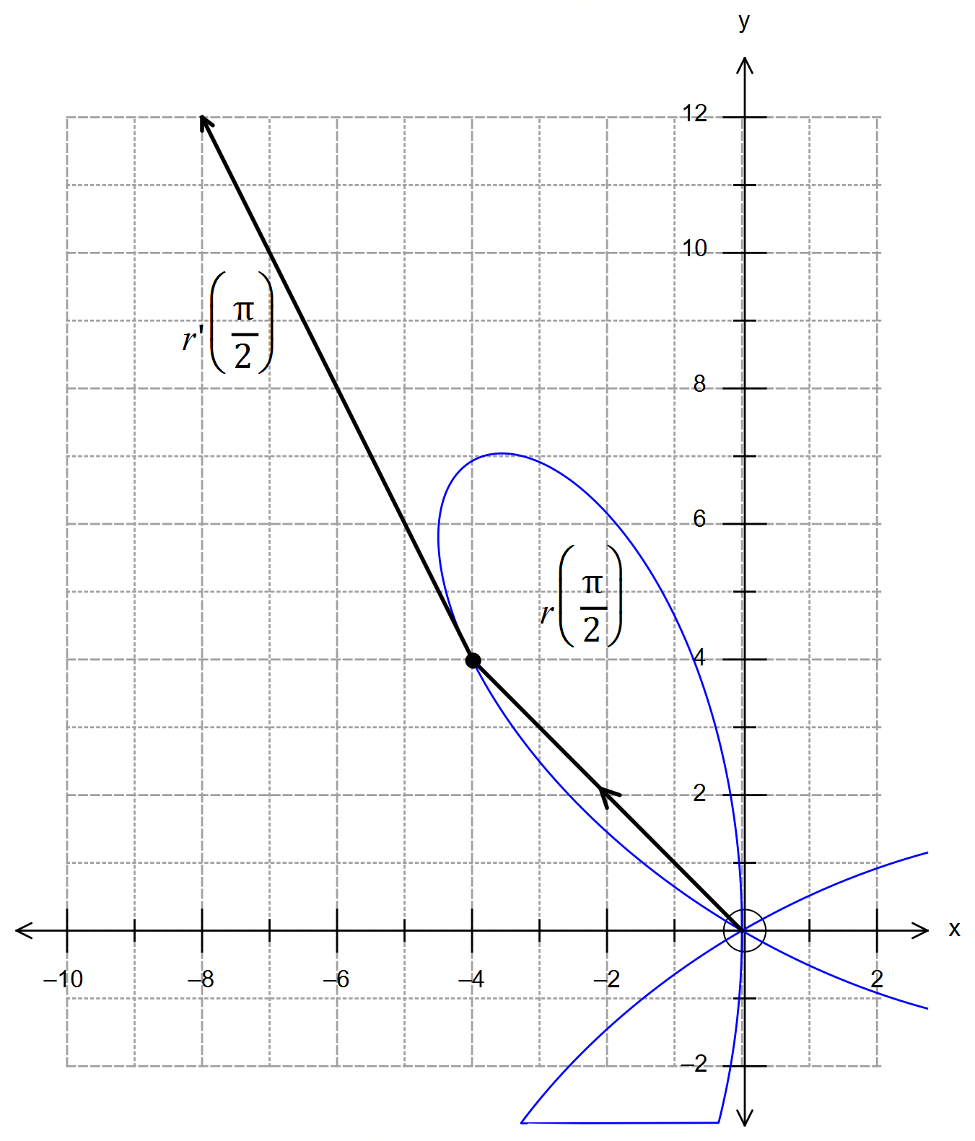18. (b) Continued.

position vector (-4, 4)
drawn from O.

velocity vector (-4, 8)
relative to (-4,4)
[i.e. drawn from (-4 ,4)]

(c) ${\left|v\right|}_{max}=4\sqrt{5+4×1}=12$ m/s
for $\sin\left(3t\right)=1 → 3t=\frac{π}{2} → t=\frac{π}{6}$
$r\left(\frac{π}{6}\right)=4\left(\begin{matrix}\cos\left(\frac{π}{6}\right)+\cos\left(\frac{π}{3}\right) \\ \sin\left(\frac{π}{6}\right)-\sin\left(\frac{π}{3}\right)\end{matrix}\right)=\left(\begin{matrix}2\sqrt{3}+2 \\ 2-2\sqrt{3}\end{matrix}\right)≈\left(\begin{matrix}5.46 \\ -1.46\end{matrix}\right)$ [9]

19. (a) the apparent “root” is in fact a discontinuity which
occurs at $\tan\left(\frac{π}{2}\right) → x+\frac{π}{6}=\frac{π}{2} → x=\frac{π}{3}$
$$∴\int_{0}^{\frac{π}{3}}{\frac{1}{\tan\left(x+\frac{π}{6}\right)}dx}=\int_{0}^{\frac{π}{3}}{\frac{\cos\left(x+\frac{π}{6}\right)}{\sin\left(x+\frac{π}{6}\right)}dx}$$
$={\left[\ln\left|\sin\left(x+\frac{π}{6}\right)\right|\right]}_{0}^{\frac{π}{3}}$
$=\ln\left|\sin\left(\frac{π}{2}\right)\right|-\ln\left|\sin\left(\frac{π}{6}\right)\right|$
$=\ln\left(1\right)-\ln\left(\frac{1}{2}\right)=\ln{{\left(\frac{1}{2}\right)}^{-1}}=\ln{2}$
(b)
$$V=π\int_{0}^{h}{{\left(\frac{r}{h}x\right)}^{2}dx}=\frac{πr^{2}}{h^{2}}\int_{0}^{h}{x^{2}dx}$$
$=\frac{πr^{2}}{h^{2}} {\left[\frac{x^{3}}{3}\right]}_{0}^{h}=\frac{πr^{2}}{h^{2}}×\frac{h^{3}}{3}=\frac{π}{3}r^{2}h$ [9]

